FOUR STAGE AND OPERATION

PROGRAM:

#include <stdio.h>

int main() { int input1, input2, input3, input4; int result;

// Take input for the four bits (0 or 1) printf("Enter the first bit (0 or 1): "); scanf("%d", &input1);

printf("Enter the second bit (0 or 1): "); scanf("%d", &input2);

printf("Enter the third bit (0 or 1): "); scanf("%d", &input3);

printf("Enter the fourth bit (0 or 1): "); scanf("%d", &input4);

// Perform 4-stage AND operation result = input1 & input2 & input3 & input4;

// Output the result printf("The result of the 4-stage AND operation is: %d\n", result);

return 0;

}

INPUT & OUTPUT:

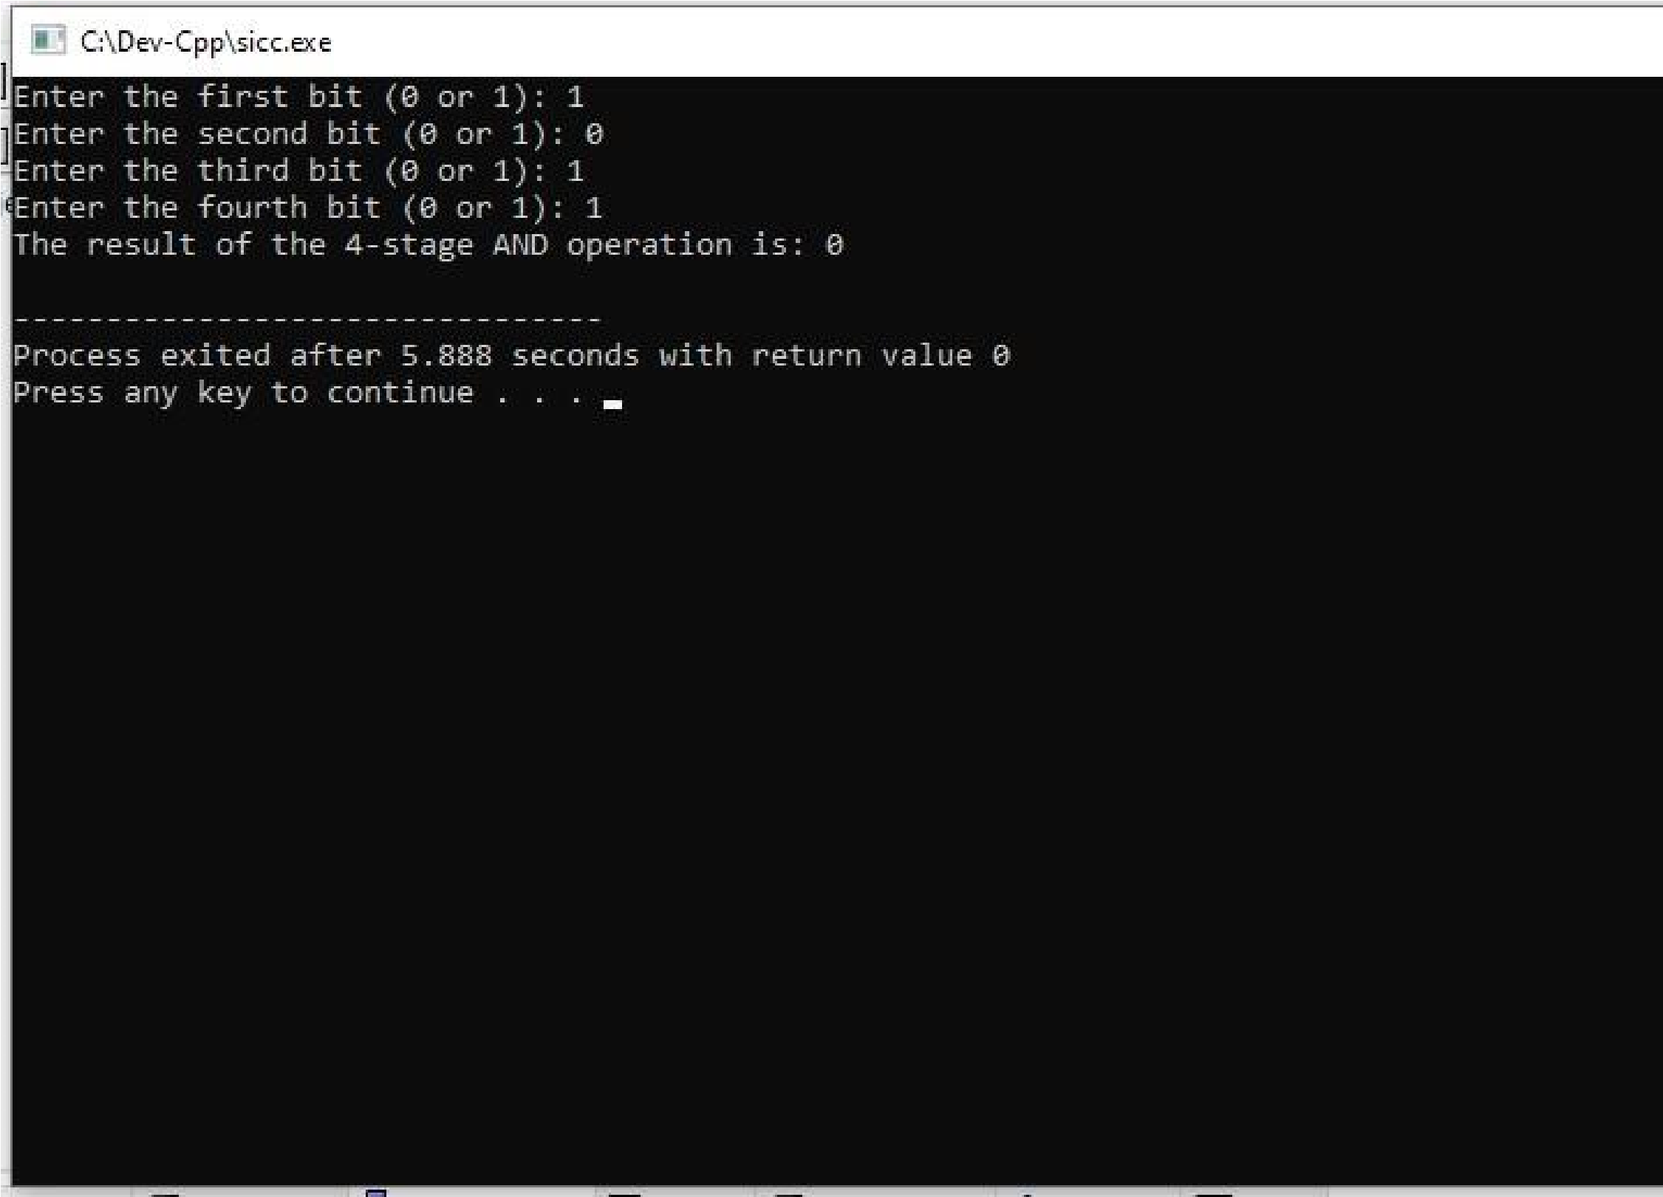

**RESULT:** Thus the program was executed successfully using DevC++.